Hanoi Twin Towers

Problem description
Given three thin pillars of sufficient length, A, B, and C, place 2n disks with holes in the middle on pillar A. These disks have n different sizes, each size has two identical disks. Note that the two disks are not discriminated (The figure below is for n=3).
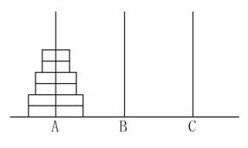
These disks are now to be moved to the pillar C, which can be temporarily stored on the pillar B during the movement. Requirements :

- Only allowed to move one disk at a time;

- The disks on A, B, C three pillars must maintain the order of small to large;

Task: let A_{n} be the minimum number of moves required by moving 2n disks to complete the above task, for the input n, output A_{n}.

Input
The input file contains a positive integer n, indicating that 2n disks are placed on pillar A.

Output
The output file contains a positive integer as the minimum number of moves A_{n} required to complete the above task.

Sample Input 1
1

Sample Output 1
2

Sample Input 2
2

Sample Output 2
6

Restriction
For 50% of the data, 1 ≤ n ≤ 25
for 100% of the data, 1 ≤ n ≤ 200

Hint
Try to establish the recursive relation between A_{n} and A_{n-1}.

